Access control

Lab 1: Creating and validating RBAC policies with Starburst Galaxy
Estimated completion time
- 30 minutes

Learning objectives
- In this lab, you will create multiple schemas and then assign appropriate role-based access policies to existing roles.

Activities
- Prepare for the exercise
- Create Human Resources schema
- Create Marketing schema
- Grant privileges to hr role
- Verify hr role’s privileges
- Grant and verify privileges to mktg role

Step 1 - Prepare for the exercise
- Sign in and verify the students role is selected in the upper-right corner.
- Ensure the aws-us-east-1-free Cluster is reporting a Status of Running.
- In the Query editor, select aws-us-east-1-free in the cluster pulldown.

Note: If you did not previously create a schema, execute the following SQL statement. Make sure that you replace yourname with your actual name, or another identifier that you prefer. Only use lowercase characters and numbers; no special characters or spaces.

CREATE SCHEMA students.yourname;

Step 2 - Create Human Resources schema
Create a schema and associated tables for the Human Resources department and load them with test data.

CREATE SCHEMA students.yourname_hr;
USE students.yourname_hr;

CREATE TABLE depts (
id int, name varchar, mgr_id int, avg_emp_rating decimal(5,3)
);
INSERT INTO depts VALUES
(501, 'Engineering', 105, 4.0),
(502, 'Sales', 102, 4.5);

CREATE TABLE emps (
id int, name varchar, dept int, rating decimal(5,3)
);
INSERT INTO emps VALUES
(101, 'Fred', 501, 4.0),
(102, 'Susan', 502, 4.5),
(103, 'Beth', 501, 5.0),
(104, 'Margo', 502, 4.5),
(105, 'John', 501, 3.0);

Query both tables to verify they contain test data.

Step 3 - Create Marketing schema
Create a schema and set of associated tables for the Marketing department. Once complete, load them with test data.

CREATE SCHEMA students.yourname_mktg;
USE students.yourname_mktg;

CREATE TABLE ext_campaign_results (
id int, client_name varchar, bogus_results varchar
);
INSERT INTO ext_campaign_results VALUES
(888, 'ABC Corp', 'nonsense nonsense'),
(888, 'XYZ LLC', 'nonsense nonsense'),
(999, 'XYX LLC', 'nonsense nonsense'),
(999, '123 Inc', 'nonsense nonsense');

CREATE TABLE int_survey_responses (
id int, dept int, bogus_response varchar
);
INSERT INTO int_survey_responses VALUES
(1101, 502, 'stuff stuff stuff'),
(1101, 501, 'stuff stuff stuff'),
(1101, 502, 'stuff stuff stuff'),
(2101, 501, 'stuff stuff stuff'),
(2101, 502, 'stuff stuff stuff');

Query both tables to verify they contain test data.

Step 4 - Grant privileges to hr role
Select Catalogs in the left navigation. Under Catalogs, in the middle pane, expand students and then yourname_hr. Click on the depts table.

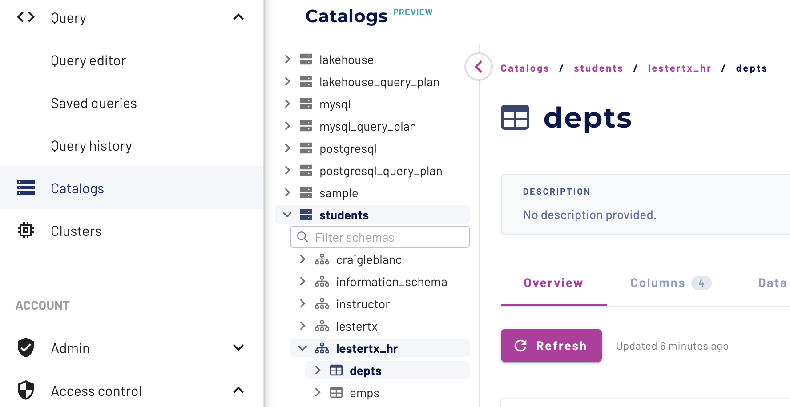

Click on the Privileges tab on the far right of the screen. Click on the Add privileges button that appears, which surfaces the Add privileges dialogue box.

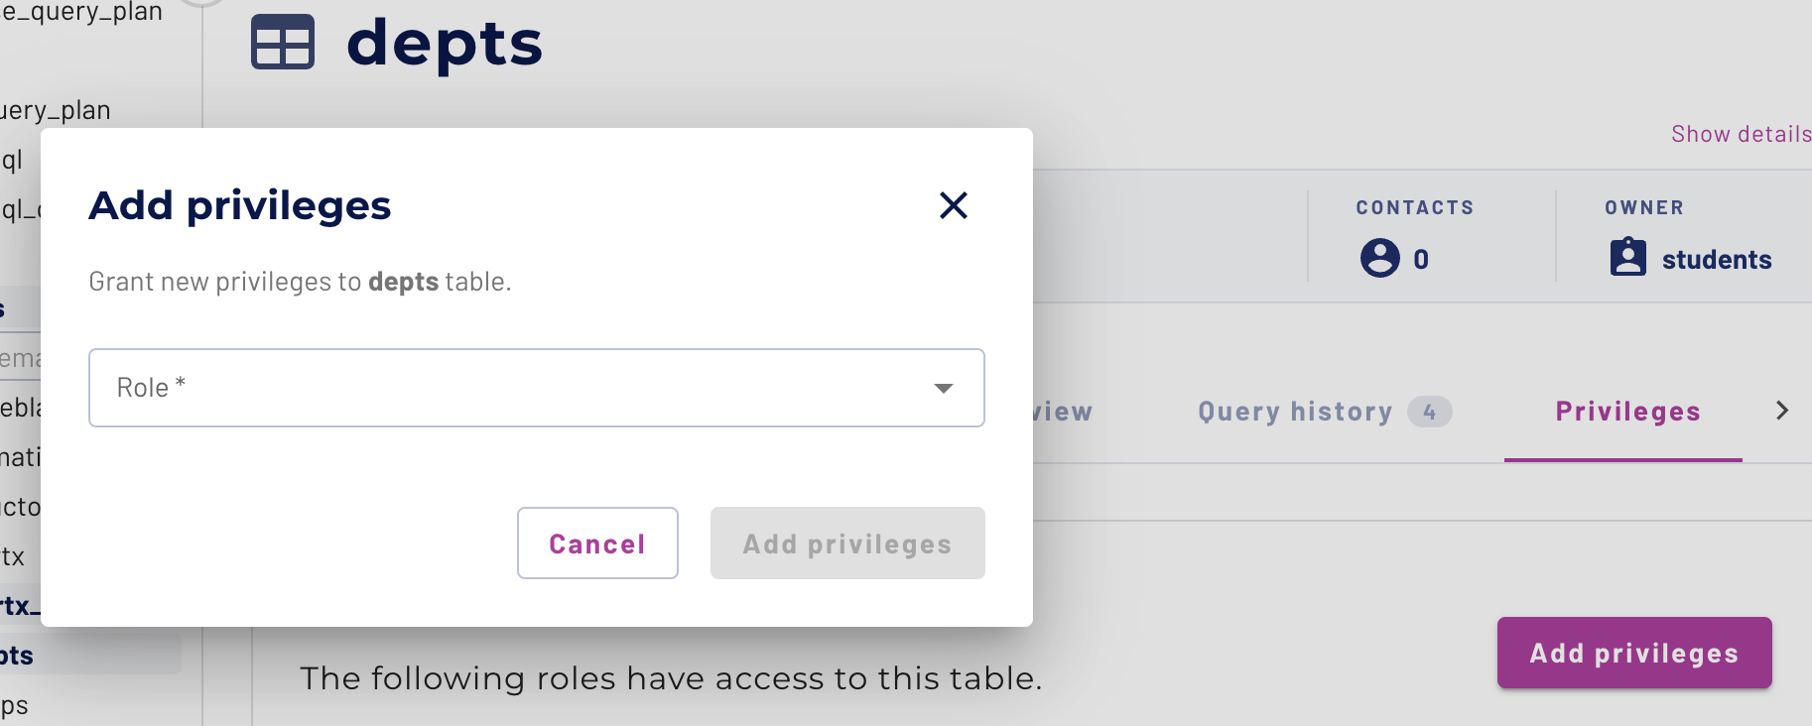

Choose the hr role in the pulldown control. Confirm that the default Allow radio button is selected.

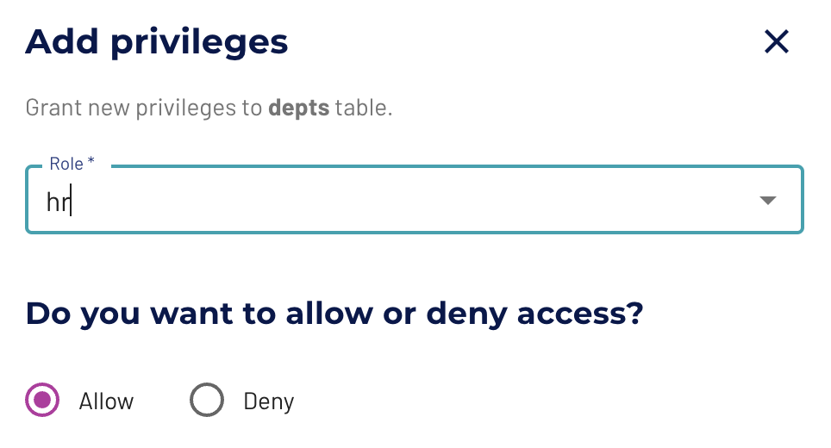

Now it’s time to select the appropriate privileges. You want to enable select rights for this table.

Check the box labeled Select from table and then click the Add privileges button.

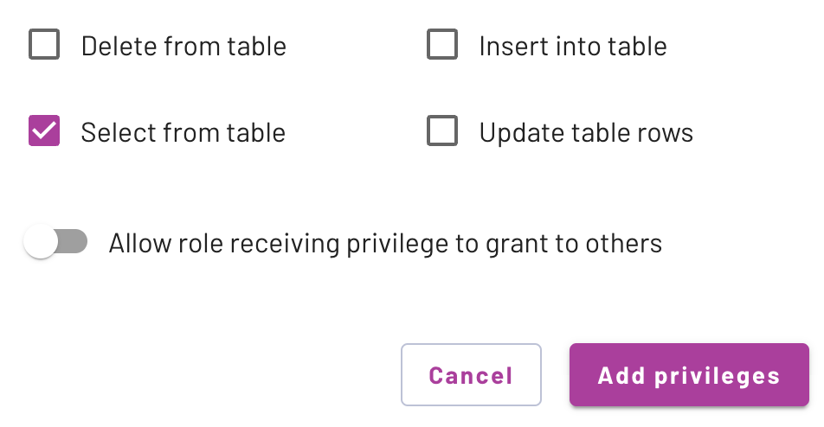

You will see a new entry in the Privileges table listing the hr role as Select from table privileges.

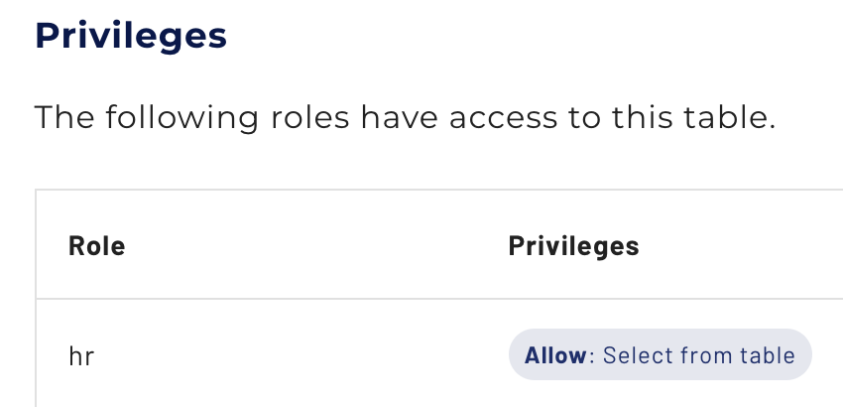

Using the same procedure, grant the same privilege to the hr role for the emps table.

Step 5 - Verify hr role’s privileges
Return to the Query editor and expand the aws-us-east-1-free cluster. You will see multiple catalogs listed.

In the upper right corner of the UI, click on the down arrow next to your email address, and hover over students in the pull-down menu that is exposed. A submenu will surface as shown below and click on hr.

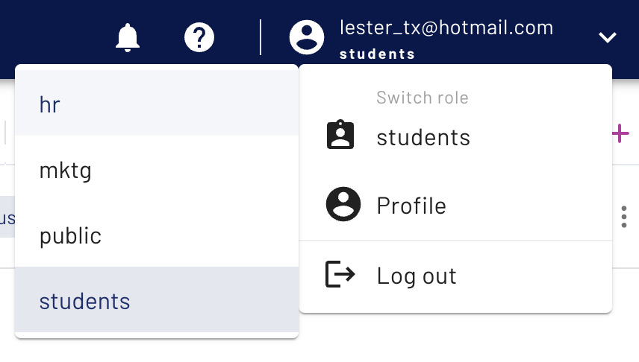

The upper right corner of the UI will now indicate your session has changed to the hr role.



The expandable cluster/catalog/schema list will now have the catalogs view collapsed. Drill back into the aws-us-east-1-free cluster and the students catalog. Beyond information_schema, you should only see the yourname_hr schema.

The depts and emps tables should be present as well. Verify that you can query both of them using the code below.

USE students.yourname_hr;

SELECT * FROM emps
JOIN depts ON (emps.dept = depts.id);

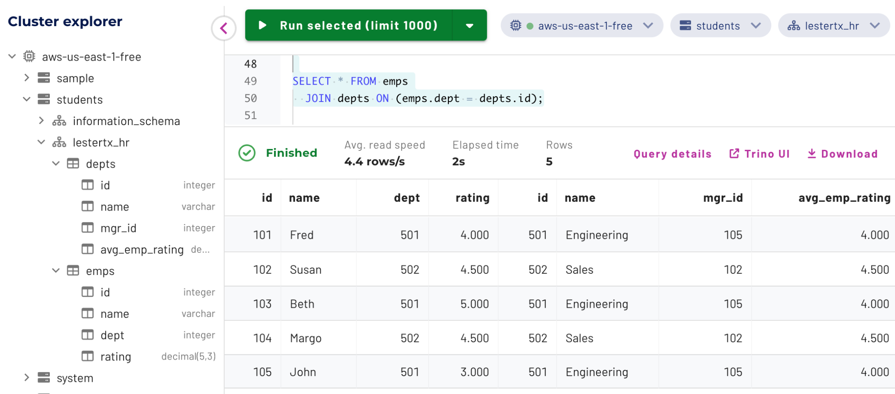

Switch to the mktg role in the upper right corner.



Verify that the students schema is not present under the cluster tree.

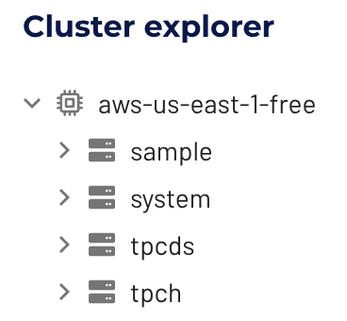

Now, switch to the students role.

Step 6 - Grant and verify privileges to mktg role
Using Steps 4 & 5 as a guide, repeat the steps to assign the two tables in the yourname_mktg schema to the mktg role. Then switch to the mktg role in the UI and verify both tables are accessible. Verify that the hr role cannot access them.

Switch back to the mktg role and execute the following query to obtain the HR department name for each record in the internal survey table using the logical foreign key that is present.

SELECT *
FROM students.yourname_mktg.int_survey_responses AS s
JOIN students.yourname_hr.depts AS d
ON (s.dept = d.id);

As you probably expected, the following appropriate error surfaced.

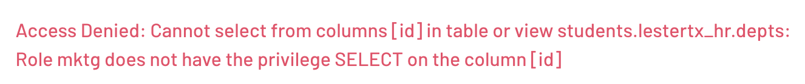

To resolve this, switch back to the students role in the UI, then grant the mktg role privileges to run SELECT statements on the depts table. Verify that the privilege is working correctly by executing the query above again in the mktg role.

END OF LAB EXERCISE

